Ten Tec TG-24 case
http://enclosures.tentec.com/Standard/TSeries/TG

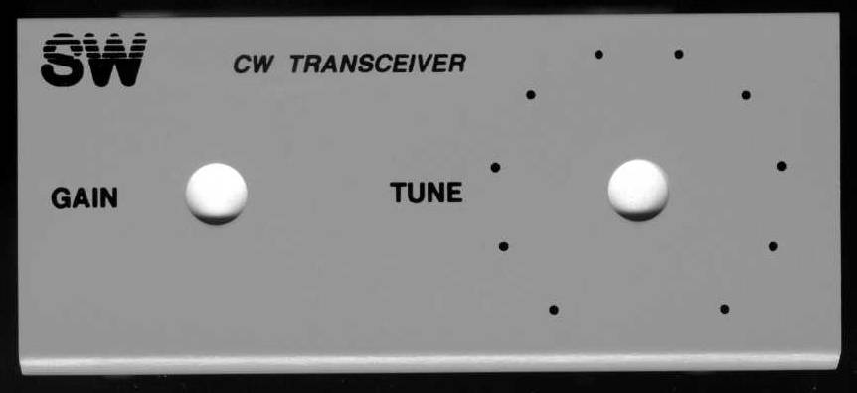

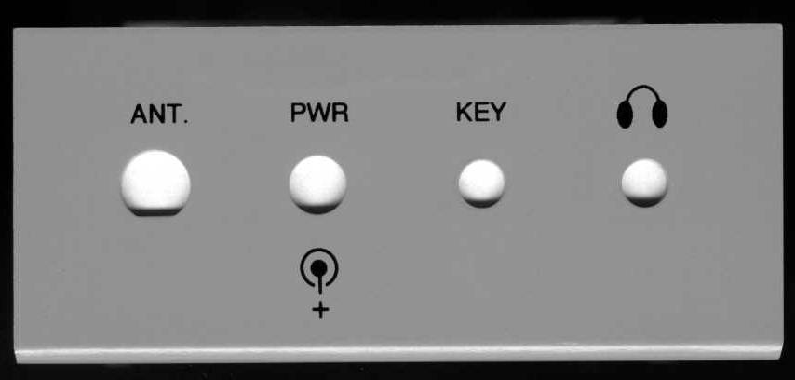
2 15/16 inches from Left side of antenna hole to Right side Headphone hole

